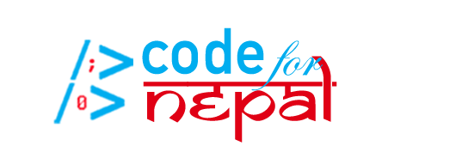

**User Documentation for Code for Nepal’s COVID-19 Resources Website**

**By Alex John, Haley Hurst, Sean O’Connor, Katie Hibner, and Mike Kenyon**

**Table of Contents**

Introduction………………………………………………………………………………………………..3

Terminology………………………………………………………………………………………………..4

Website Prototype Overview………………………………………………………………………5-9

How to change the language of the website……………………………………………………10

How to search for specific information………………………………………………………...11

How to go to a new website page……………………………………………………………..12-13

How to find a test center…………………………………………………………………………14-15

When you should seek emergency services…..…………………………….………..15

When you should seek testing…………………………………………………………….15

How to find a COVID-19 vaccine center…………………………………………….……..16-17

How to add a test center to the database…………………………………………………..18-19

How to add a vaccine center to the database…………………………………………….20-21

**1a.) Introduction**

This website prototype was created by students at Virginia Tech in an effort to make knowledge about testing and vaccines more accessible to citizens of Nepal. This website should allow users to collectively benefit from and contribute to the effort to make information about COVID-19 testing and vaccinations more accessible. After using the checklists on the “COVID-19 Information” page, the user should be able to self-evaluate their symptoms and exposure in order to establish whether or not they should seek testing or emergency medical assistance. If they find that their symptoms and exposure warrant a test, they should then be able to find their closest COVID-19 test center by utilizing the “Find a Test Center” page. If the user knows of a test center that exists but is not listed in our database, they can fill out the form on the “Add Test Centers to Database” page. If the user needs additional resources, they can use the More Resources tab to find helpful information about COVID-19, helpful vocabulary, transportation resources, and frequently asked questions. Users can use external links, such as to the World Health Organization (WHO) website, and embedded products, such as interactive maps and COVID-19 trackers, for further access to information. With the help of this document, users will be able to digitally access, and even contribute, information about COVID-19 and testing and vaccine centers on the website. This addresses the current disaster that the pandemic poses and helps increase digital literacy.

The objectives of the prototype include increasing accessibility to important information regarding COVID-19, specifically testing and vaccine centers, by creating an all-encompassing resource and user documentation to aid users in their use of the source and their digital literacy. These objectives reflect Code for Nepal’s mission of increasing digital literacy and therefore, increasing accessibility to information, so included in the website are informational sections about Code for Nepal and their slack channel, website, and social media. Overall, this prototype is meant to provide an accessible resource for essential information surrounding the global disaster, COVID-19.

The user documentation is designed so that users can find the information they need without having to read the entire document. The descriptive Table of Contents provides a brief overview of the document’s contents, so that users can identify which section(s) will best fit their needs. Because users will navigate the website through unique user journeys, our step-by-step tutorials are split into sections and each begin with the opening up of the website to the homepage, rather than a chronological tutorial of how to navigate the whole website.

**1b.) Terminology:**

Throughout this document, several terms referring to COVID-19, its safety mitigation, and digital literacy will be mentioned. Many of these terms are defined in the prototype in the *Helpful Vocabulary* tab under the *More Resources* button. The terms that are most relevant to this documentation are defined below:

* **COVID-19**:
  + The novel coronavirus that was discovered in 2019 and is the source of the international pandemic that was declared on March 11, 2020.
  + This virus sometimes mimics flu-like symptoms (a complete list of symptoms can be found on page 15) and attacks the respiratory system.
* **Database:**
  + A collection of information.
* **Exposure:**
  + Close contact with an individual that is infected with COVID-19.
  + Close contact includes being within 1.83 meters (6 feet) from an individual who has tested positive for COVID-19 or who is displaying symptoms that align with COVID-19 symptoms.
* **External link:**
  + Clickable words or images that, when clicked, will take you to another webpage.
* **Test Centers:**
  + Medical facilities that administer nasopharyngeal (nose) swab tests that can detect the presence of the COVID-19 virus in the individual being tested.
* **Text:**
  + The written content on the website prototype.
* **Vaccine:**
  + A product given to an individual, usually through a shot, to provide active immunity against a specific virus.
* **Vaccine Centers:**
  + Medical facilities that administer the COVID-19 vaccine when the vaccine becomes publicly available.
* **Website Page:**
  + A section of the website that includes specific information.
  + Each page can be navigated to through the buttons at the top of the screen.

**2.) Website Prototype Overview:**

This document acts as a guide for using Code for Nepal’s COVID-19 Resources website prototype. The website sections are listed below in the same order as the menu buttons:

* **Home Page** *(Home button)*
  + This page provides an introduction and guide to the website. It outlines the website objectives and contains buttons that will take you to the other pages of the website, an interactive map of hospital locations, a COVID-19 tracker to keep you informed, and information about Code for Nepal.

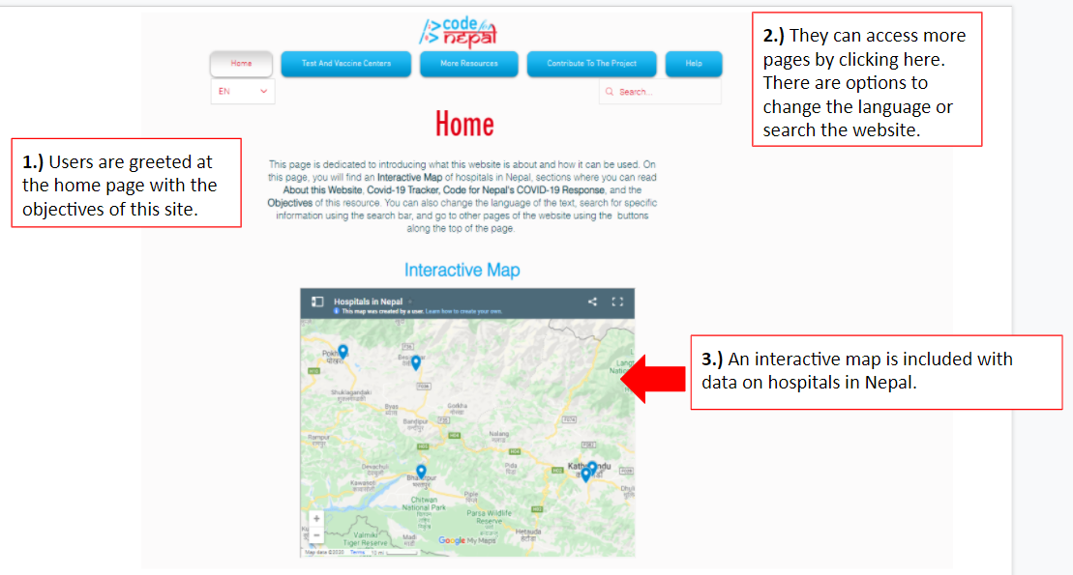

* **Find a Test Center** *(Test and Vaccine Centers button)*
  + This page allows you to find testing centers by typing your location in the search bar as directed. The nearest testing centers will be shown on the map.
  + Directions for using this page are written directly on the page and are also outlined in this document, in section *6.) How to find a test center.*

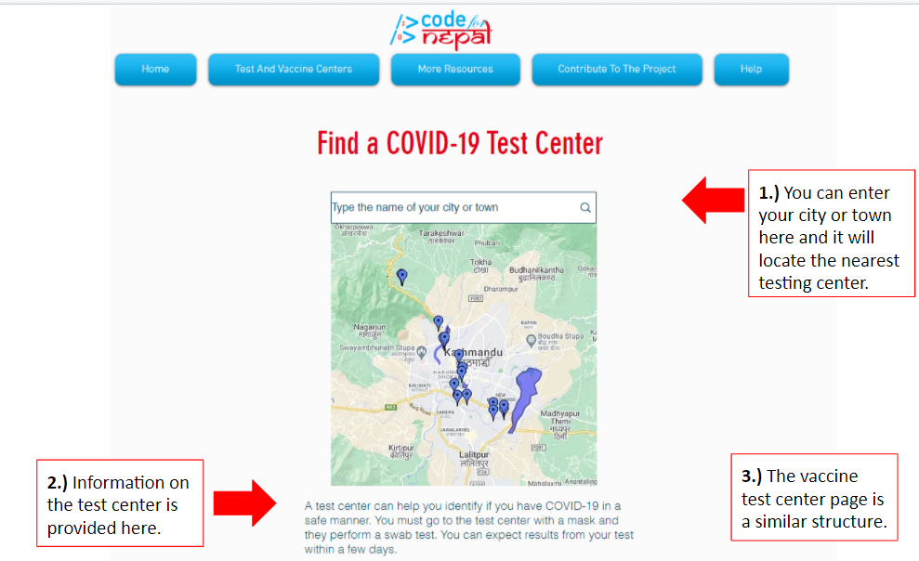

* **Test Center Database** *(Test and Vaccine Centers button)*
  + This page holds a spreadsheet of all the known test centers in Nepal for users to have access to if they would rather see a list than results on the map. The test center database is continuously updated, based on the feedback of the user.

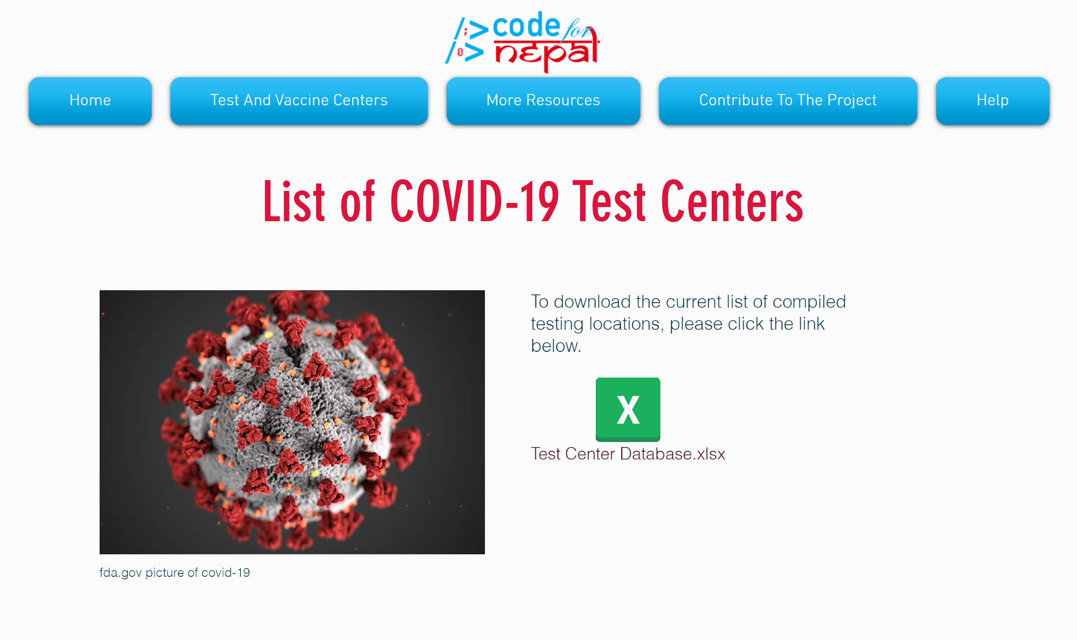

* **Transportation Resources** *(More Resources button)*
  + This page contains external links to transportation resources to help you get to test and vaccine centers.
  + It also has a map of bus, taxi and walking routes to major Nepalese cities.

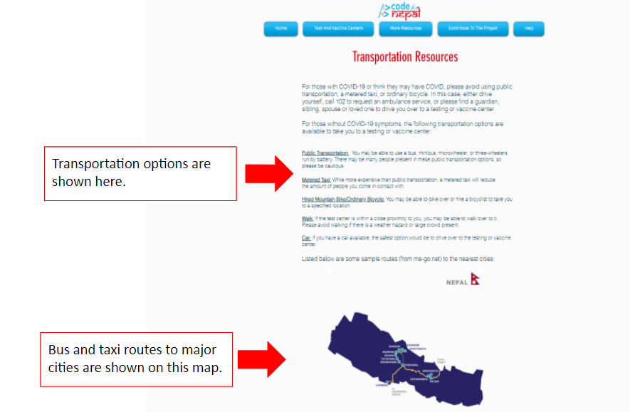

* **Frequently Asked Questions Page** *(More Resources button)*
  + This page serves to answer more specific questions. These are questions about information that was mentioned in other pages but not described in detail, so this page attempts to answer questions you may have about the website content.

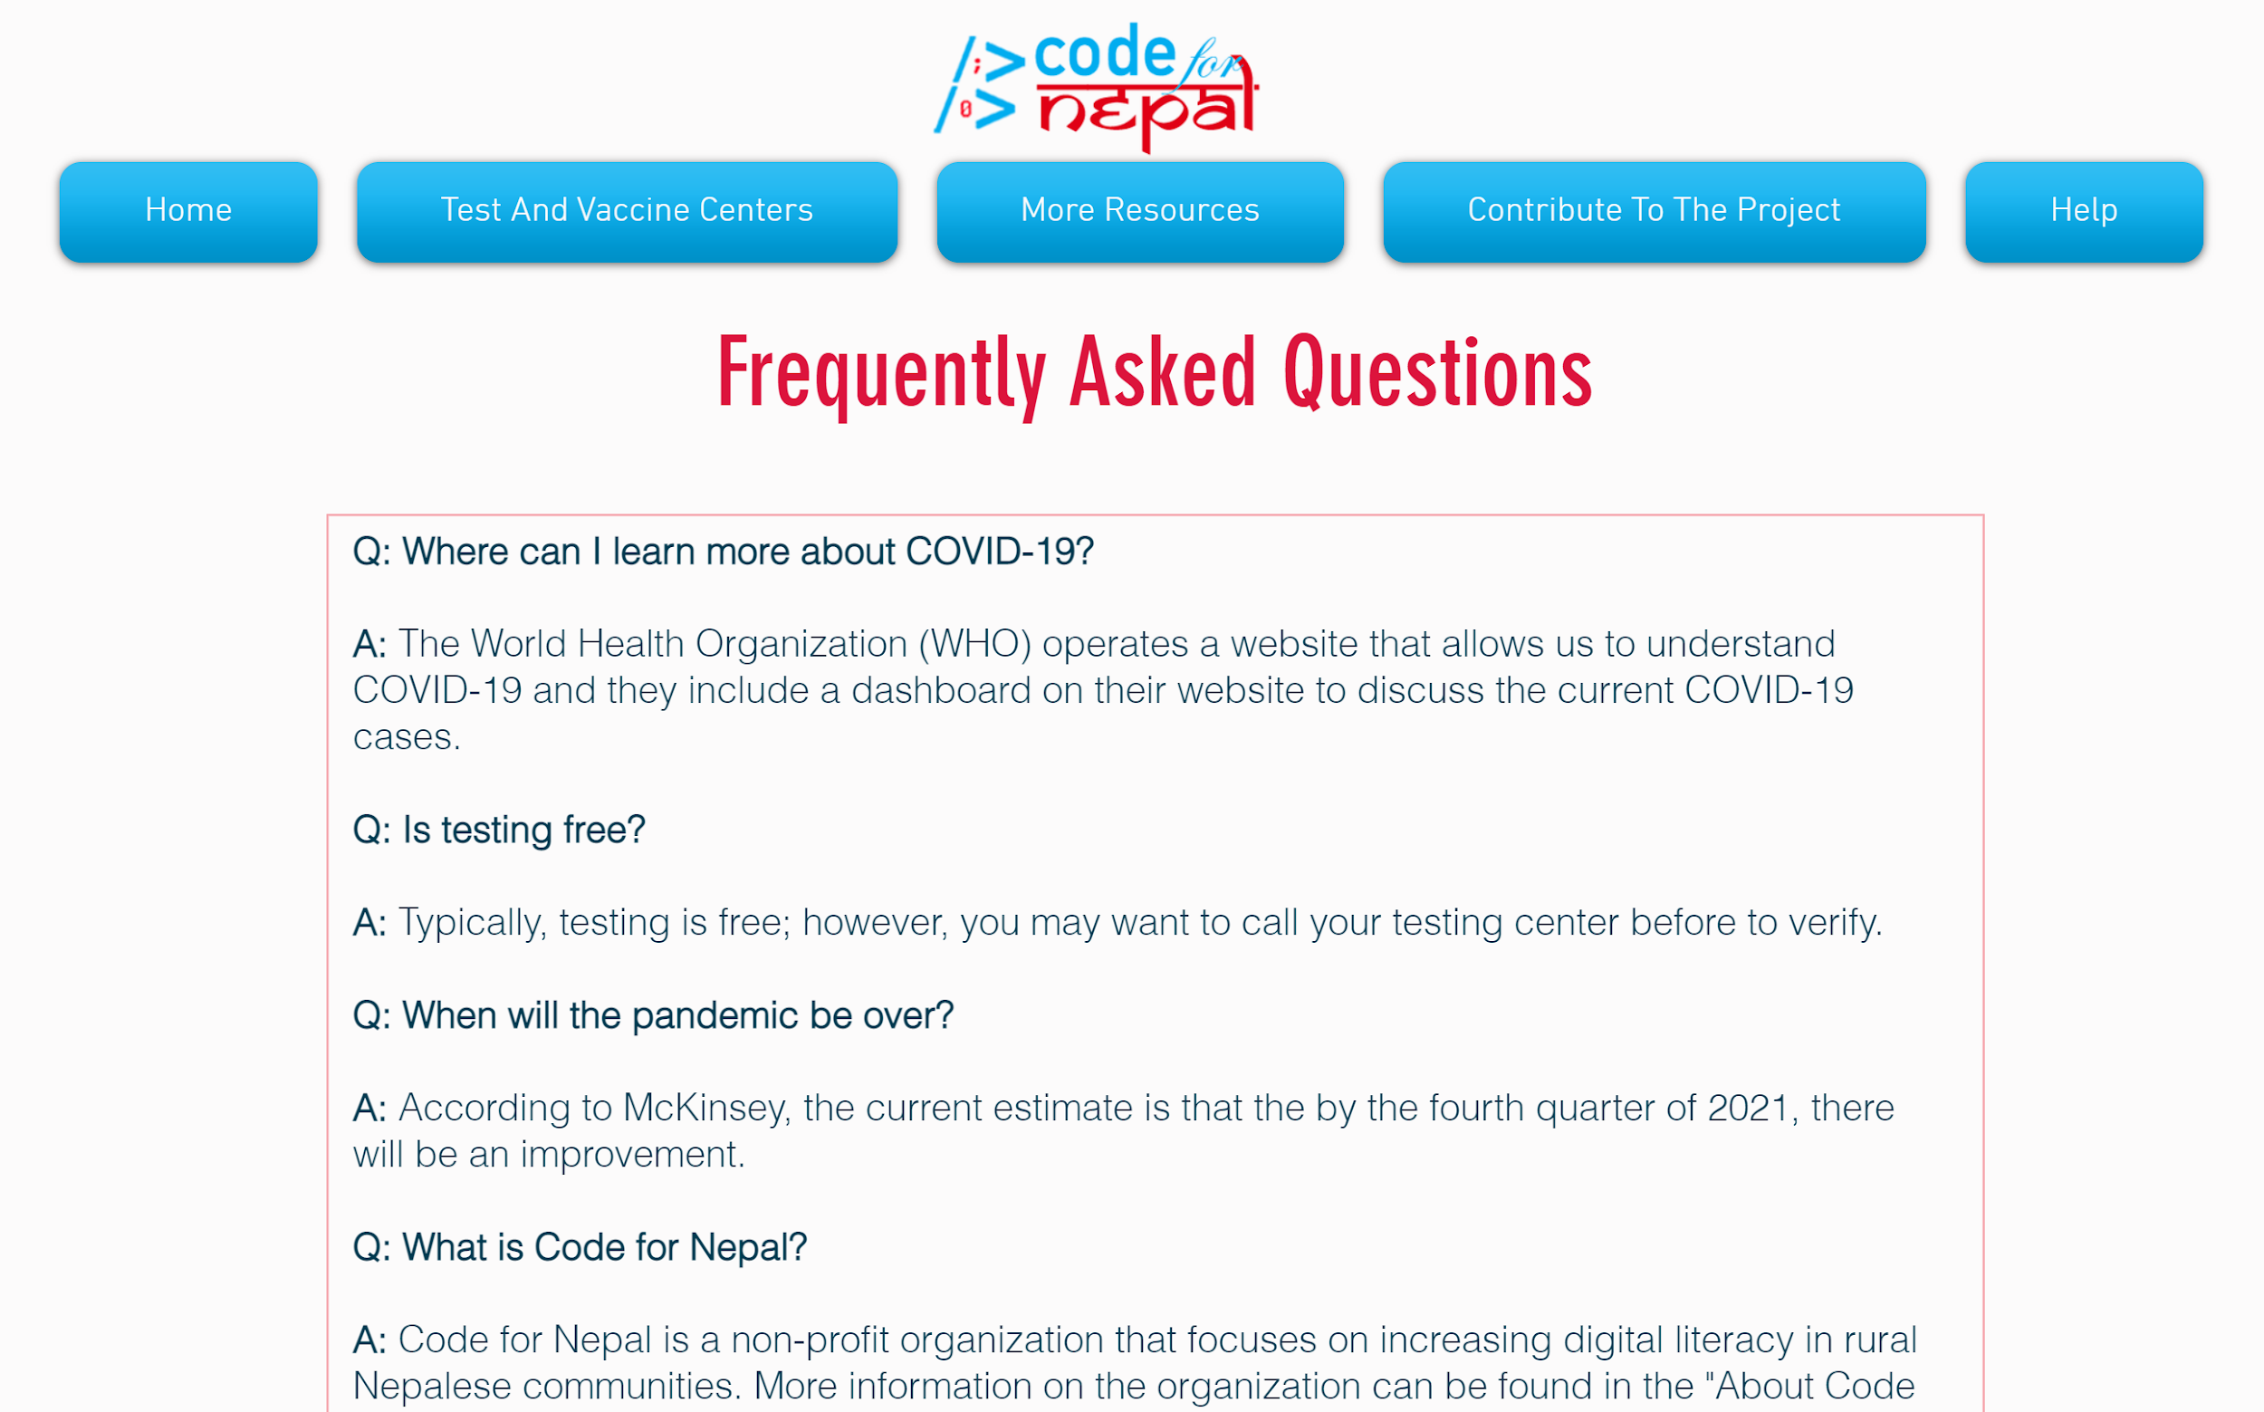

* **Additional Resources** *(More Resources button)*
  + This page is used to refer you to other sources of information for COVID-19 as well as to other Code for Nepal resources. Next to each source, there is a short description to help you decide whether that source will be useful to you.
  + We have embedded external links to Code for Nepal’s website and slack channel and an external link to the WHO website.

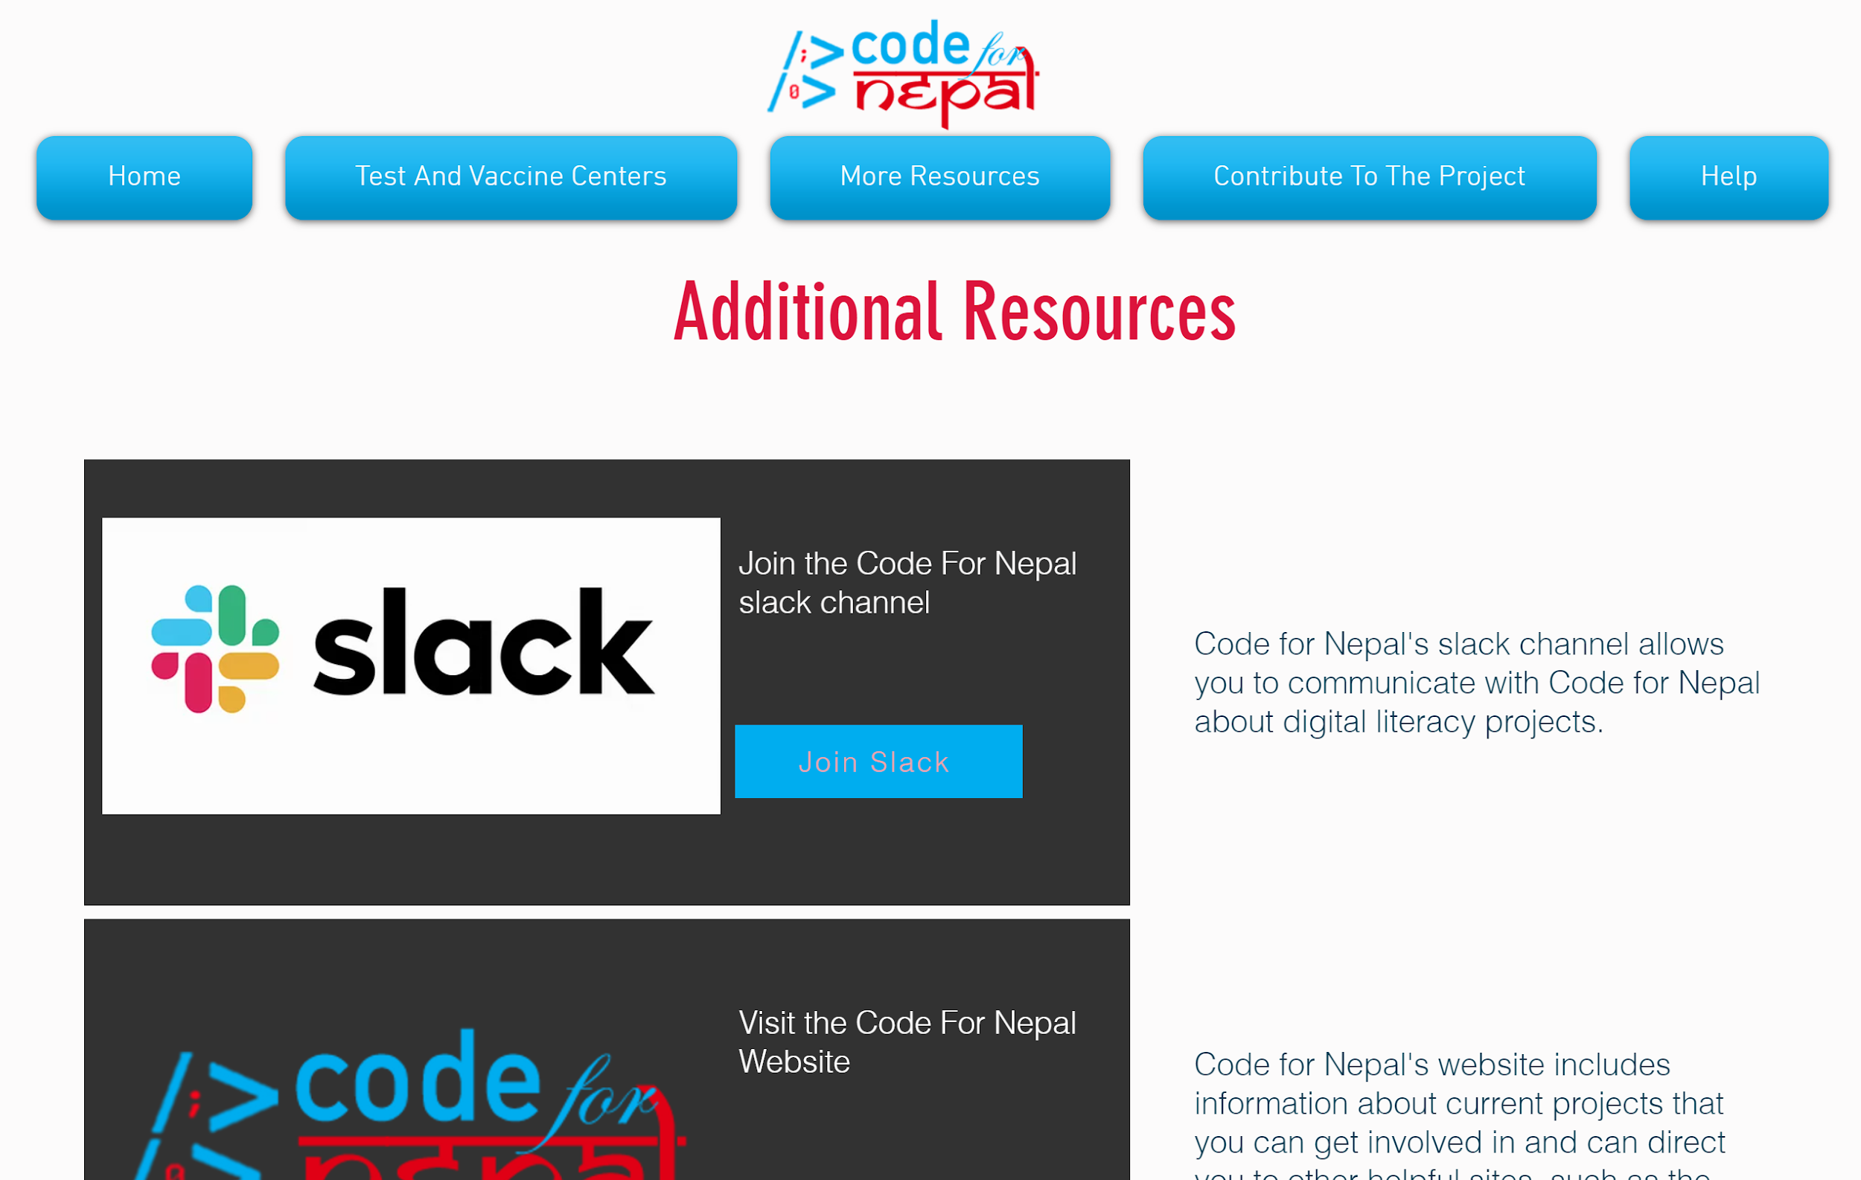

* **COVID-19 Information Page** *(More Resources button)*
  + This page provides essential information about COVID-19, including when to seek emergency services, testing information regarding symptoms and exposure guidelines, and the current status of a vaccine.
  + This page also features an external link to Nepal’s Ministry of Health and Population’s COVID-19 database.

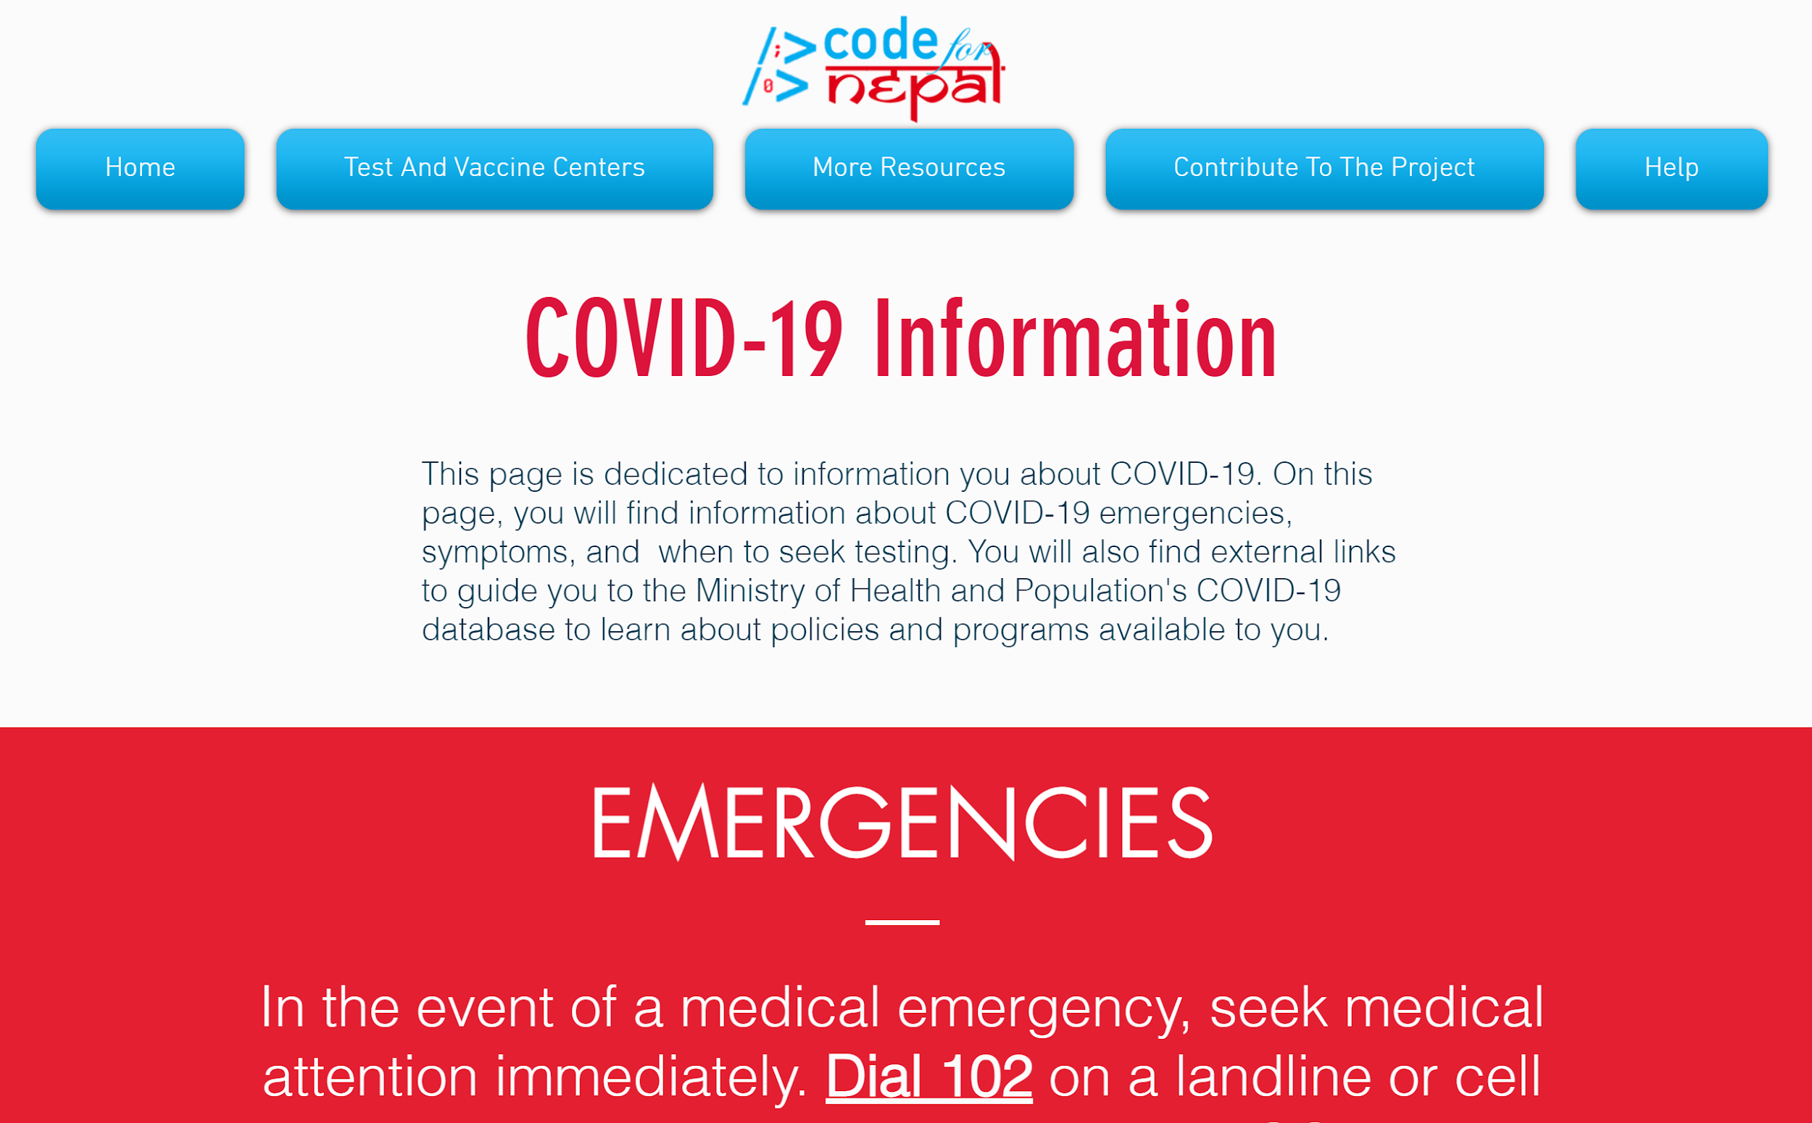

* **Add Test Centers to the Database** *(Contribute To The Project button)*
  + This page enables you to submit testing center information that is not included in the database. It has a form you can fill out to report new or unlisted test centers so that the website developers can ensure the database is up to date.
  + Instructions are provided at the bottom of the website page and in this document, in section *9) How to add a test center to the database*.

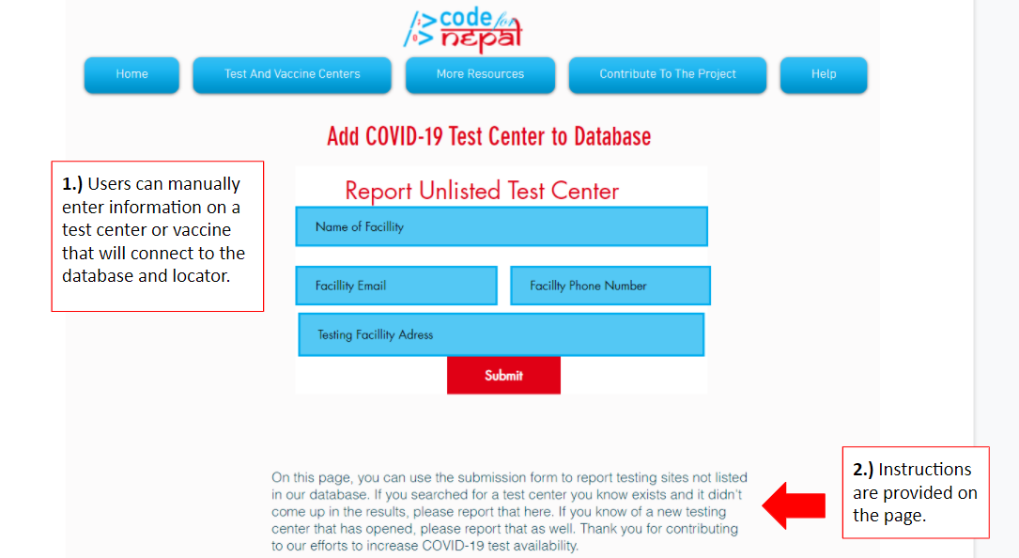

* **About Code for Nepal** *(Help button)*
  + This page offers more information on Code for Nepal and its mission.
  + It contains an informative video about Code for Nepal and links to direct you to more Code for Nepal resources.

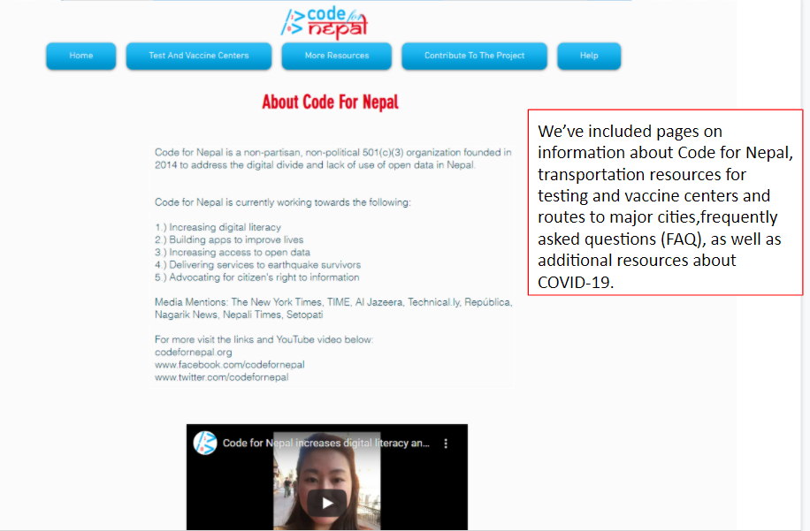

* **How to Use This Website** *(Help button)*
  + This page serves as a directory of the website prototype and summarizes the features and uses of each page in the website.
  + Each section is clearly labelled and written to match the language in the top buttons for ease and clarity. 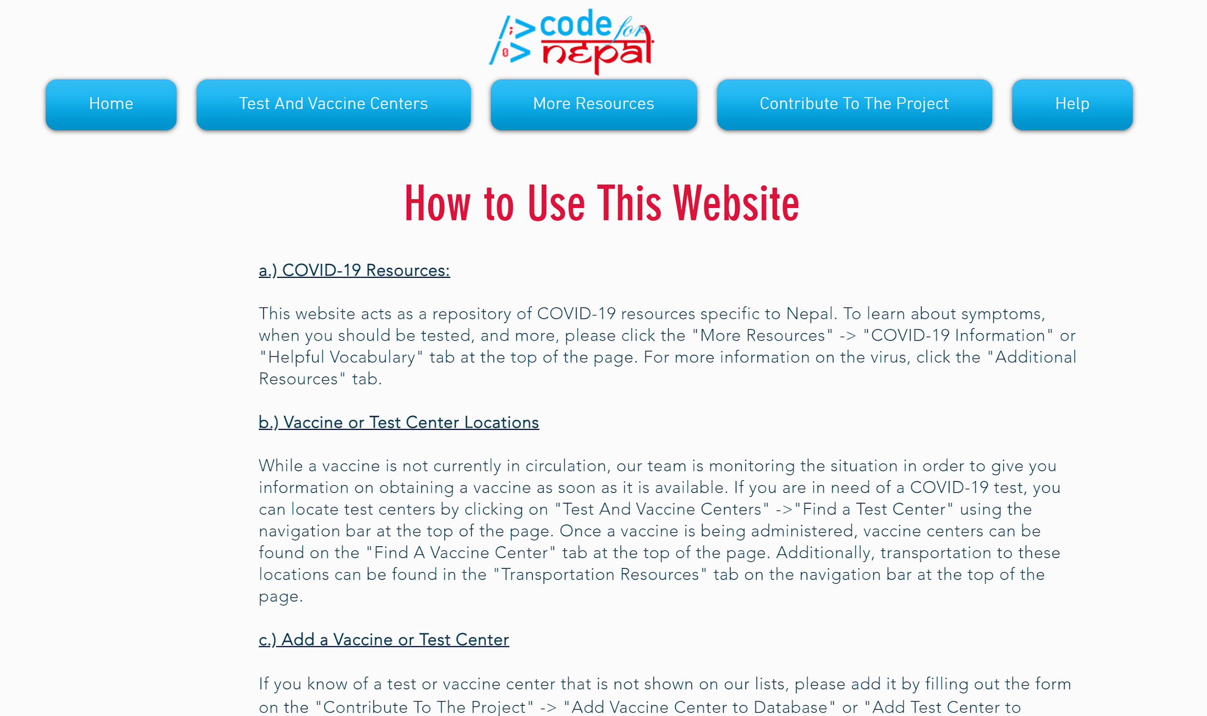

**3.) How to Change the Language of the Website:**

1. Open the Code For Nepal COVID-19 Resource website by typing **[insert HTML link here]** into your internet browser. You should see the home page on your screen, pictured below:

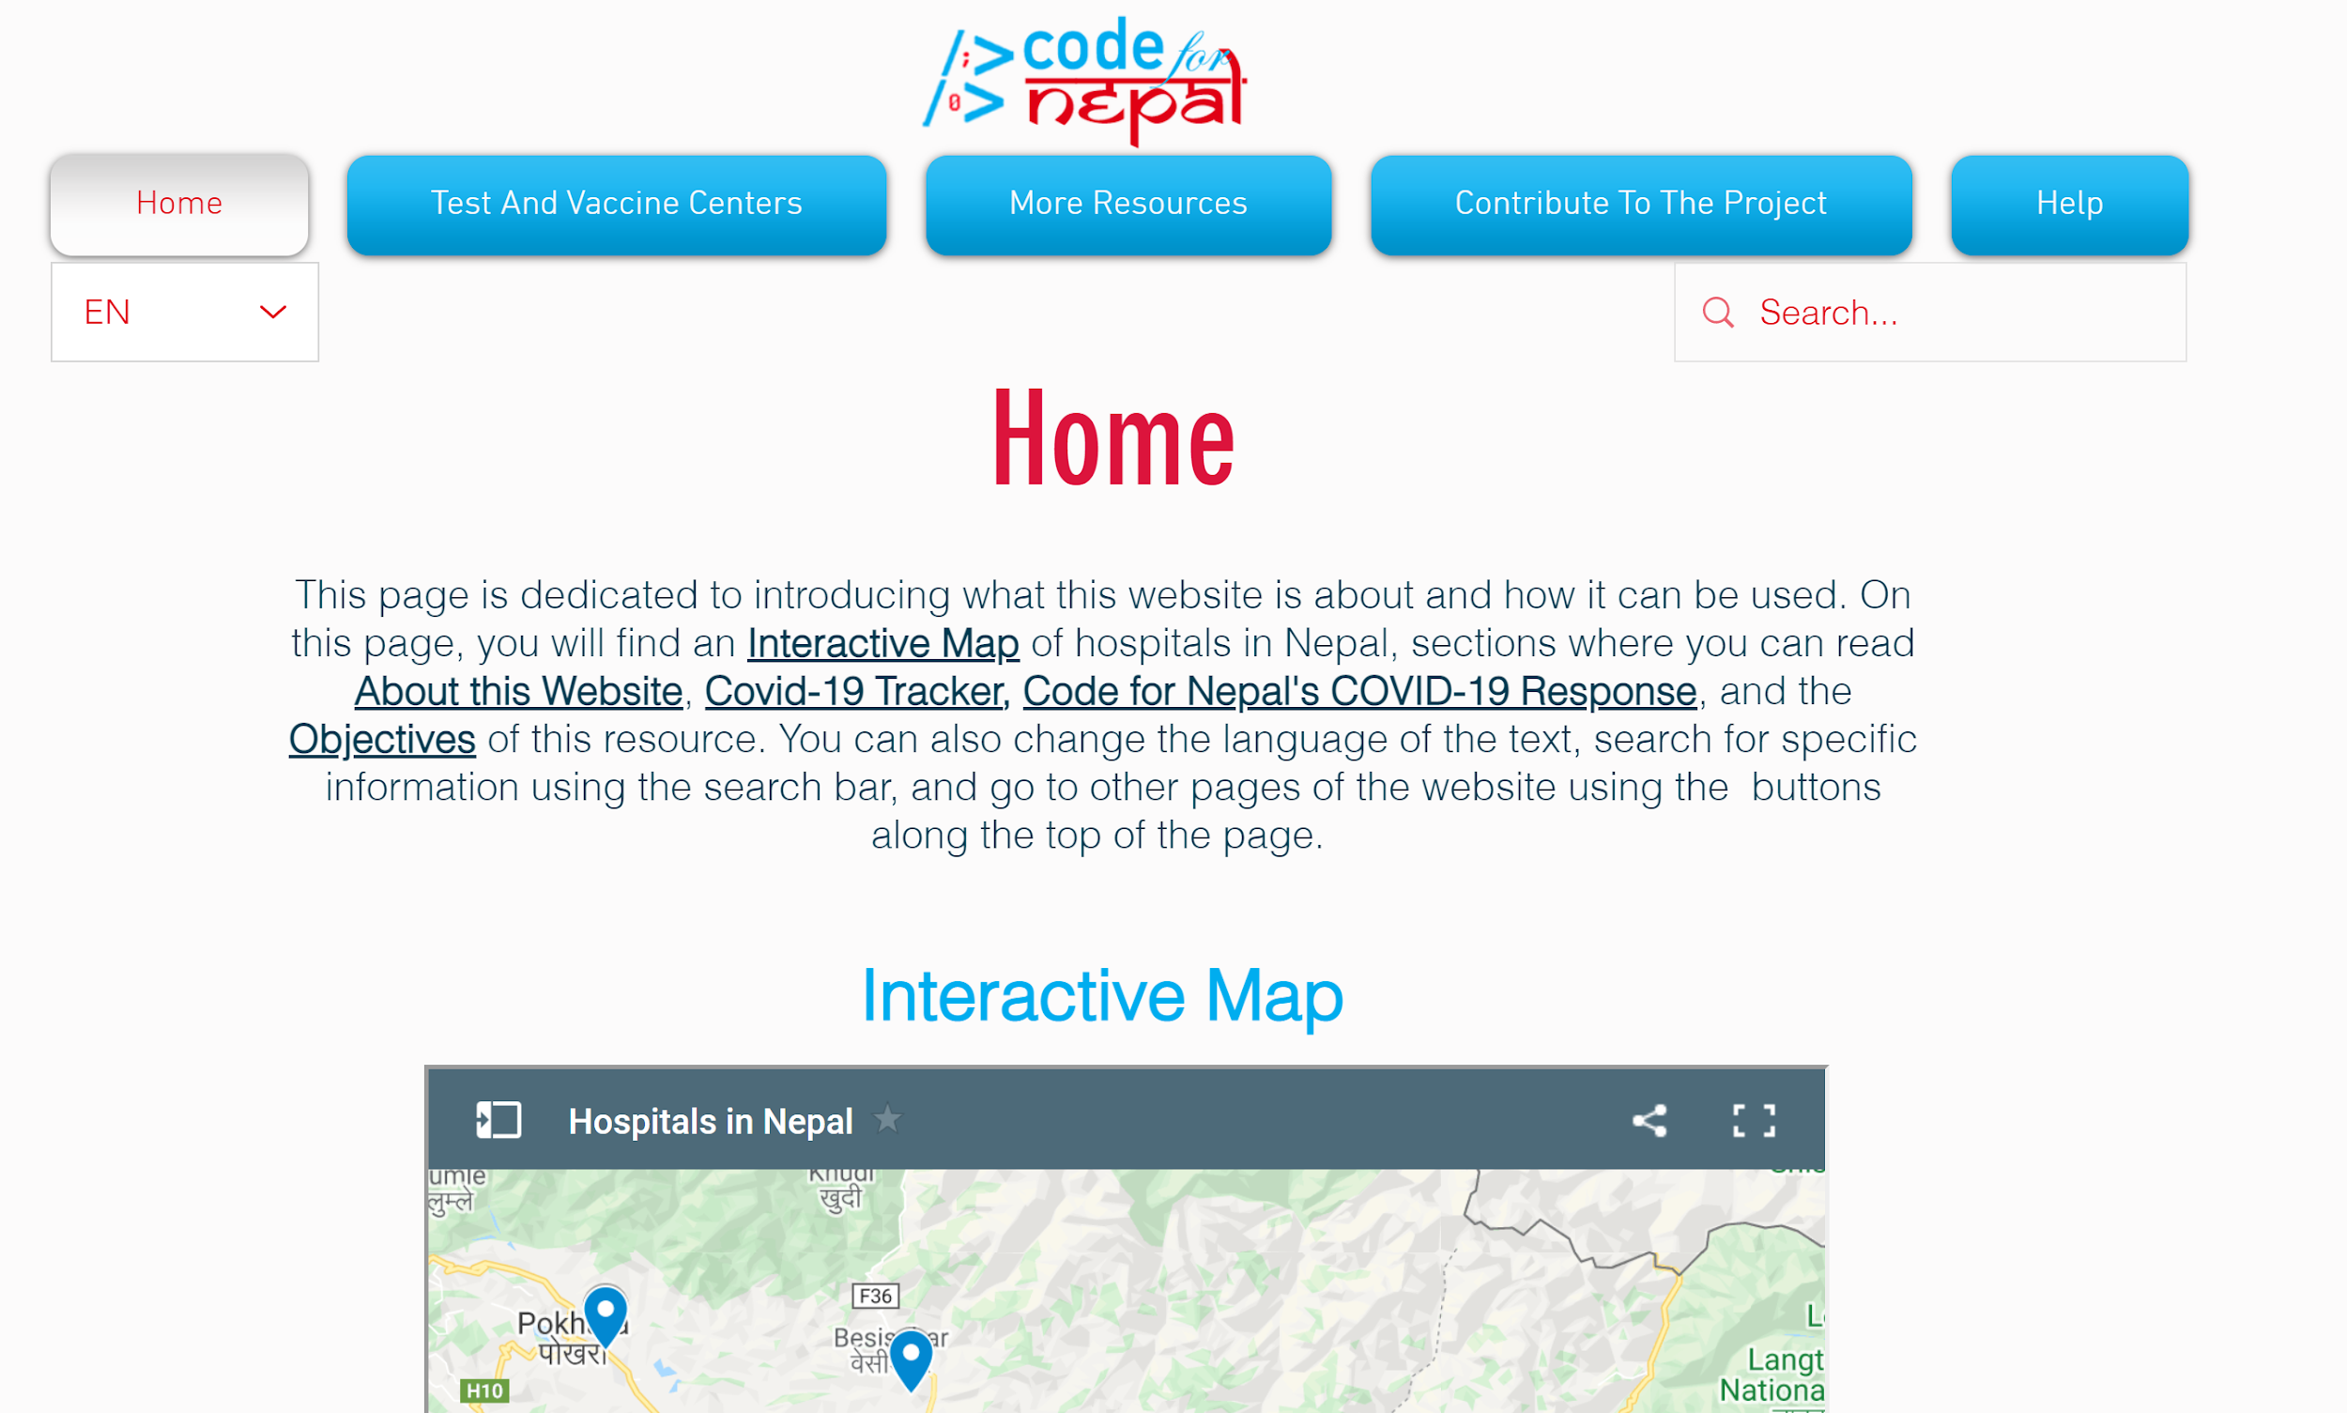

1. In the white rectangle under the *Home* button, you will see a language option and drop down arrow. It is outlined in red in the picture below.

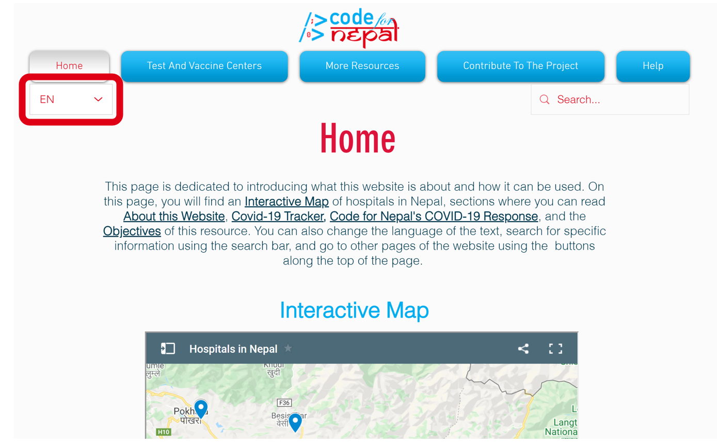

1. Click on the downward facing arrow to view the text language options.

Options include:

* 1. English
  2. Hindi
  3. Nepali

1. Place your cursor on the language you prefer, then click. The text will translate automatically.

**4.) How to Search for Specific Information:**

1. Open the Code For Nepal COVID-19 Resource website by typing **[insert HTML link here]** into your internet browser. You should see the home page on your screen, pictured below:



1. Click inside the white rectangle at the top right of the screen that says Search. This is the Search bar, outlined in red in the picture below.

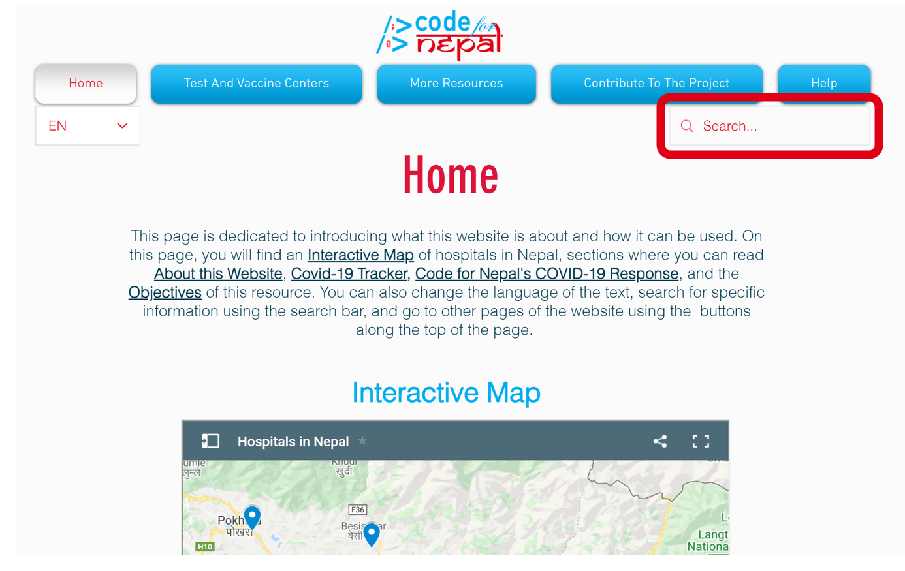

1. Type in the information you are looking for and press “Enter” on your keyboard. The results will appear.
2. You can repeat this process to search for new information.

**5.) How to Go To a New Website Page:**

1. Open the Code For Nepal COVID-19 Resource website by typing **[insert HTML link here]** into your internet browser. You should see the home page on your screen, pictured below:



1. At the top of your screen, notice the blue menu buttons, outlined in red in the picture below. Remember, you are currently on the **Home** page.

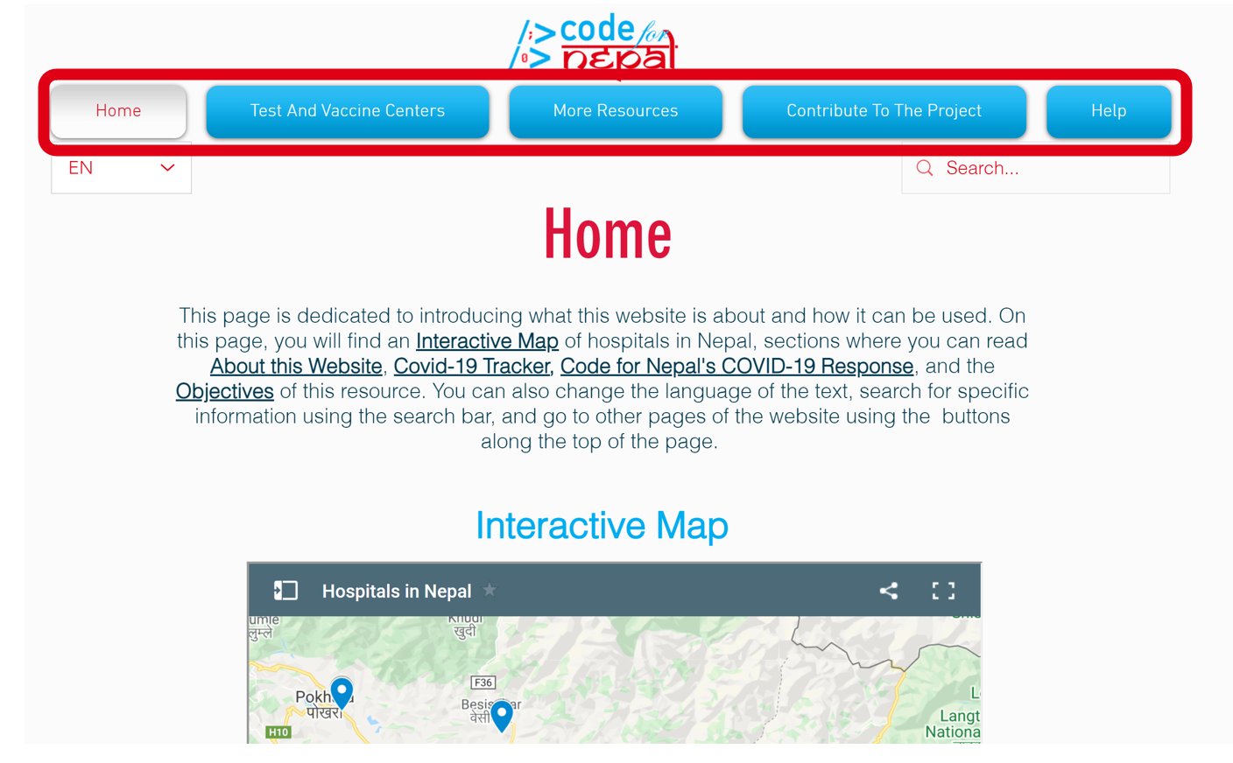

1. If you want to find testing centers or vaccine center information, click the **Test and Vaccine Centers** button. This drop down menu will appear:

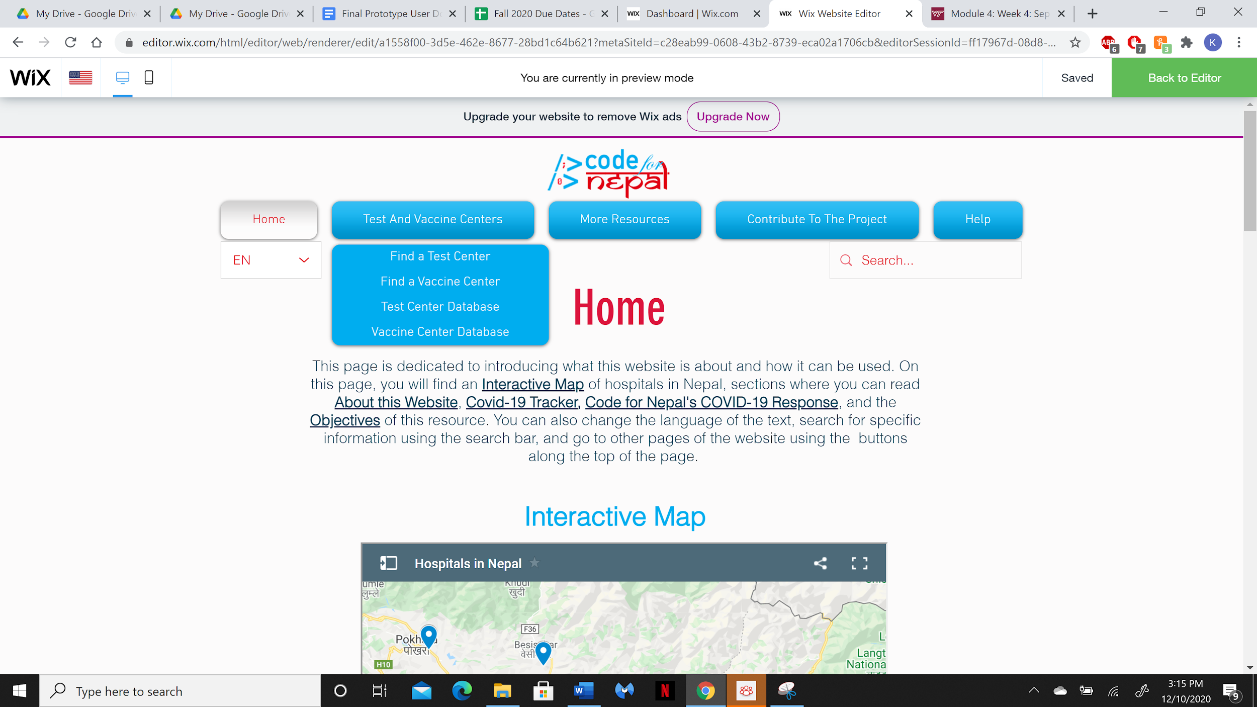

1. Click on the line of text that matches your needs. You will be directed to that page.
2. If you have questions about words used on the website, transportation resources or the COVID-19 virus, click the **More Resources** button. This drop down menu will appear:

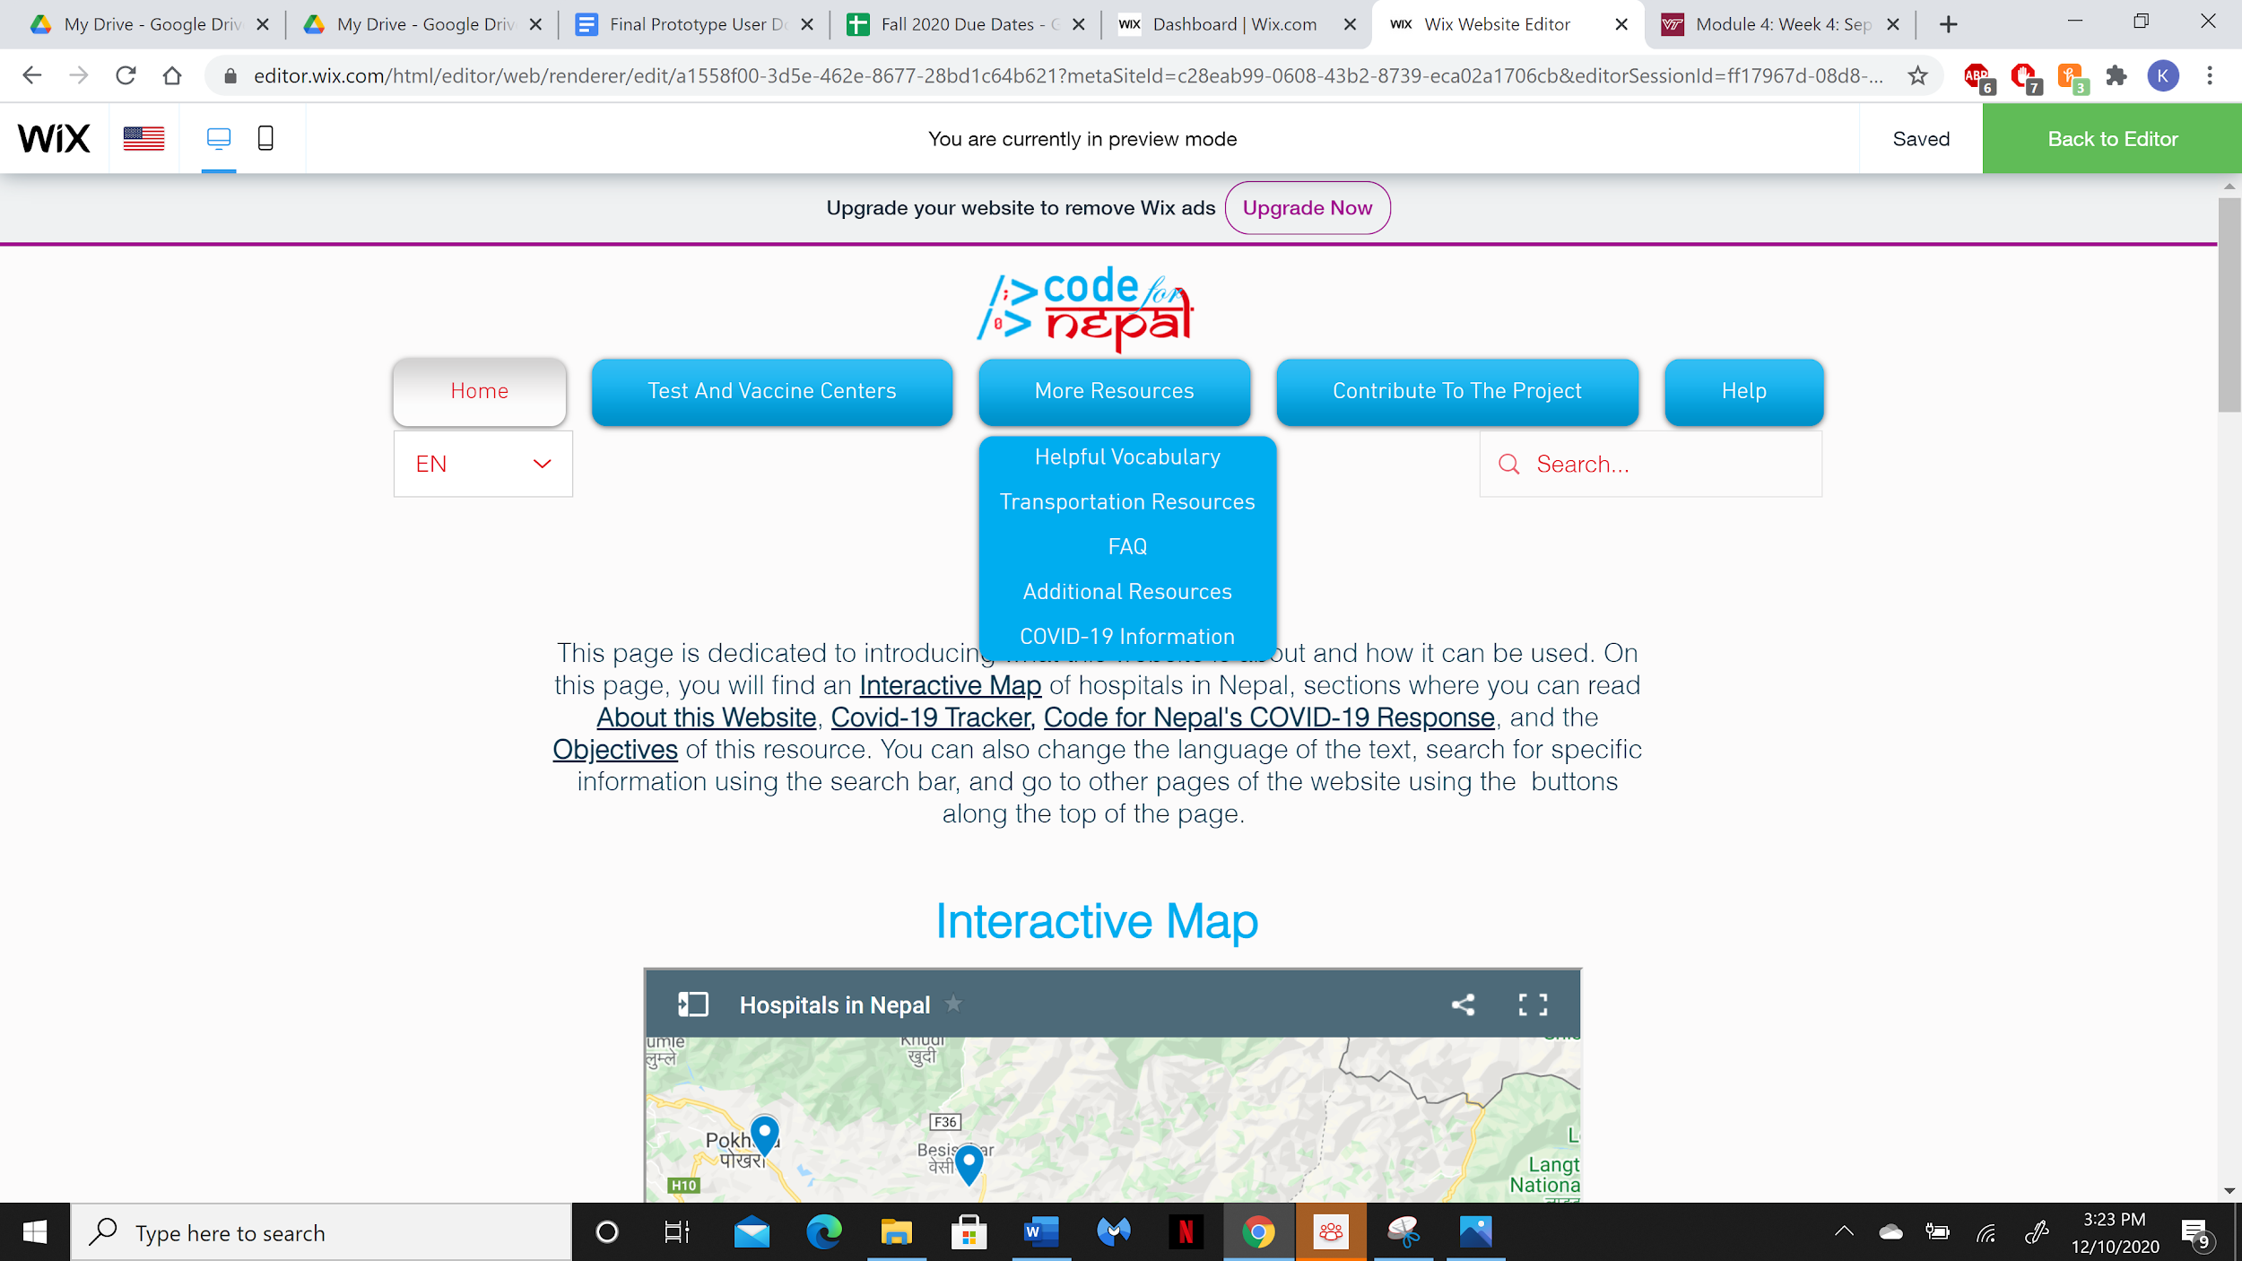

1. Click on the line of text that matches your needs. You will be directed to that page.
2. If you have information about test or vaccine centers and would like to add that information to the website database, click the **Contribute To The Project** button. This drop down menu will appear:

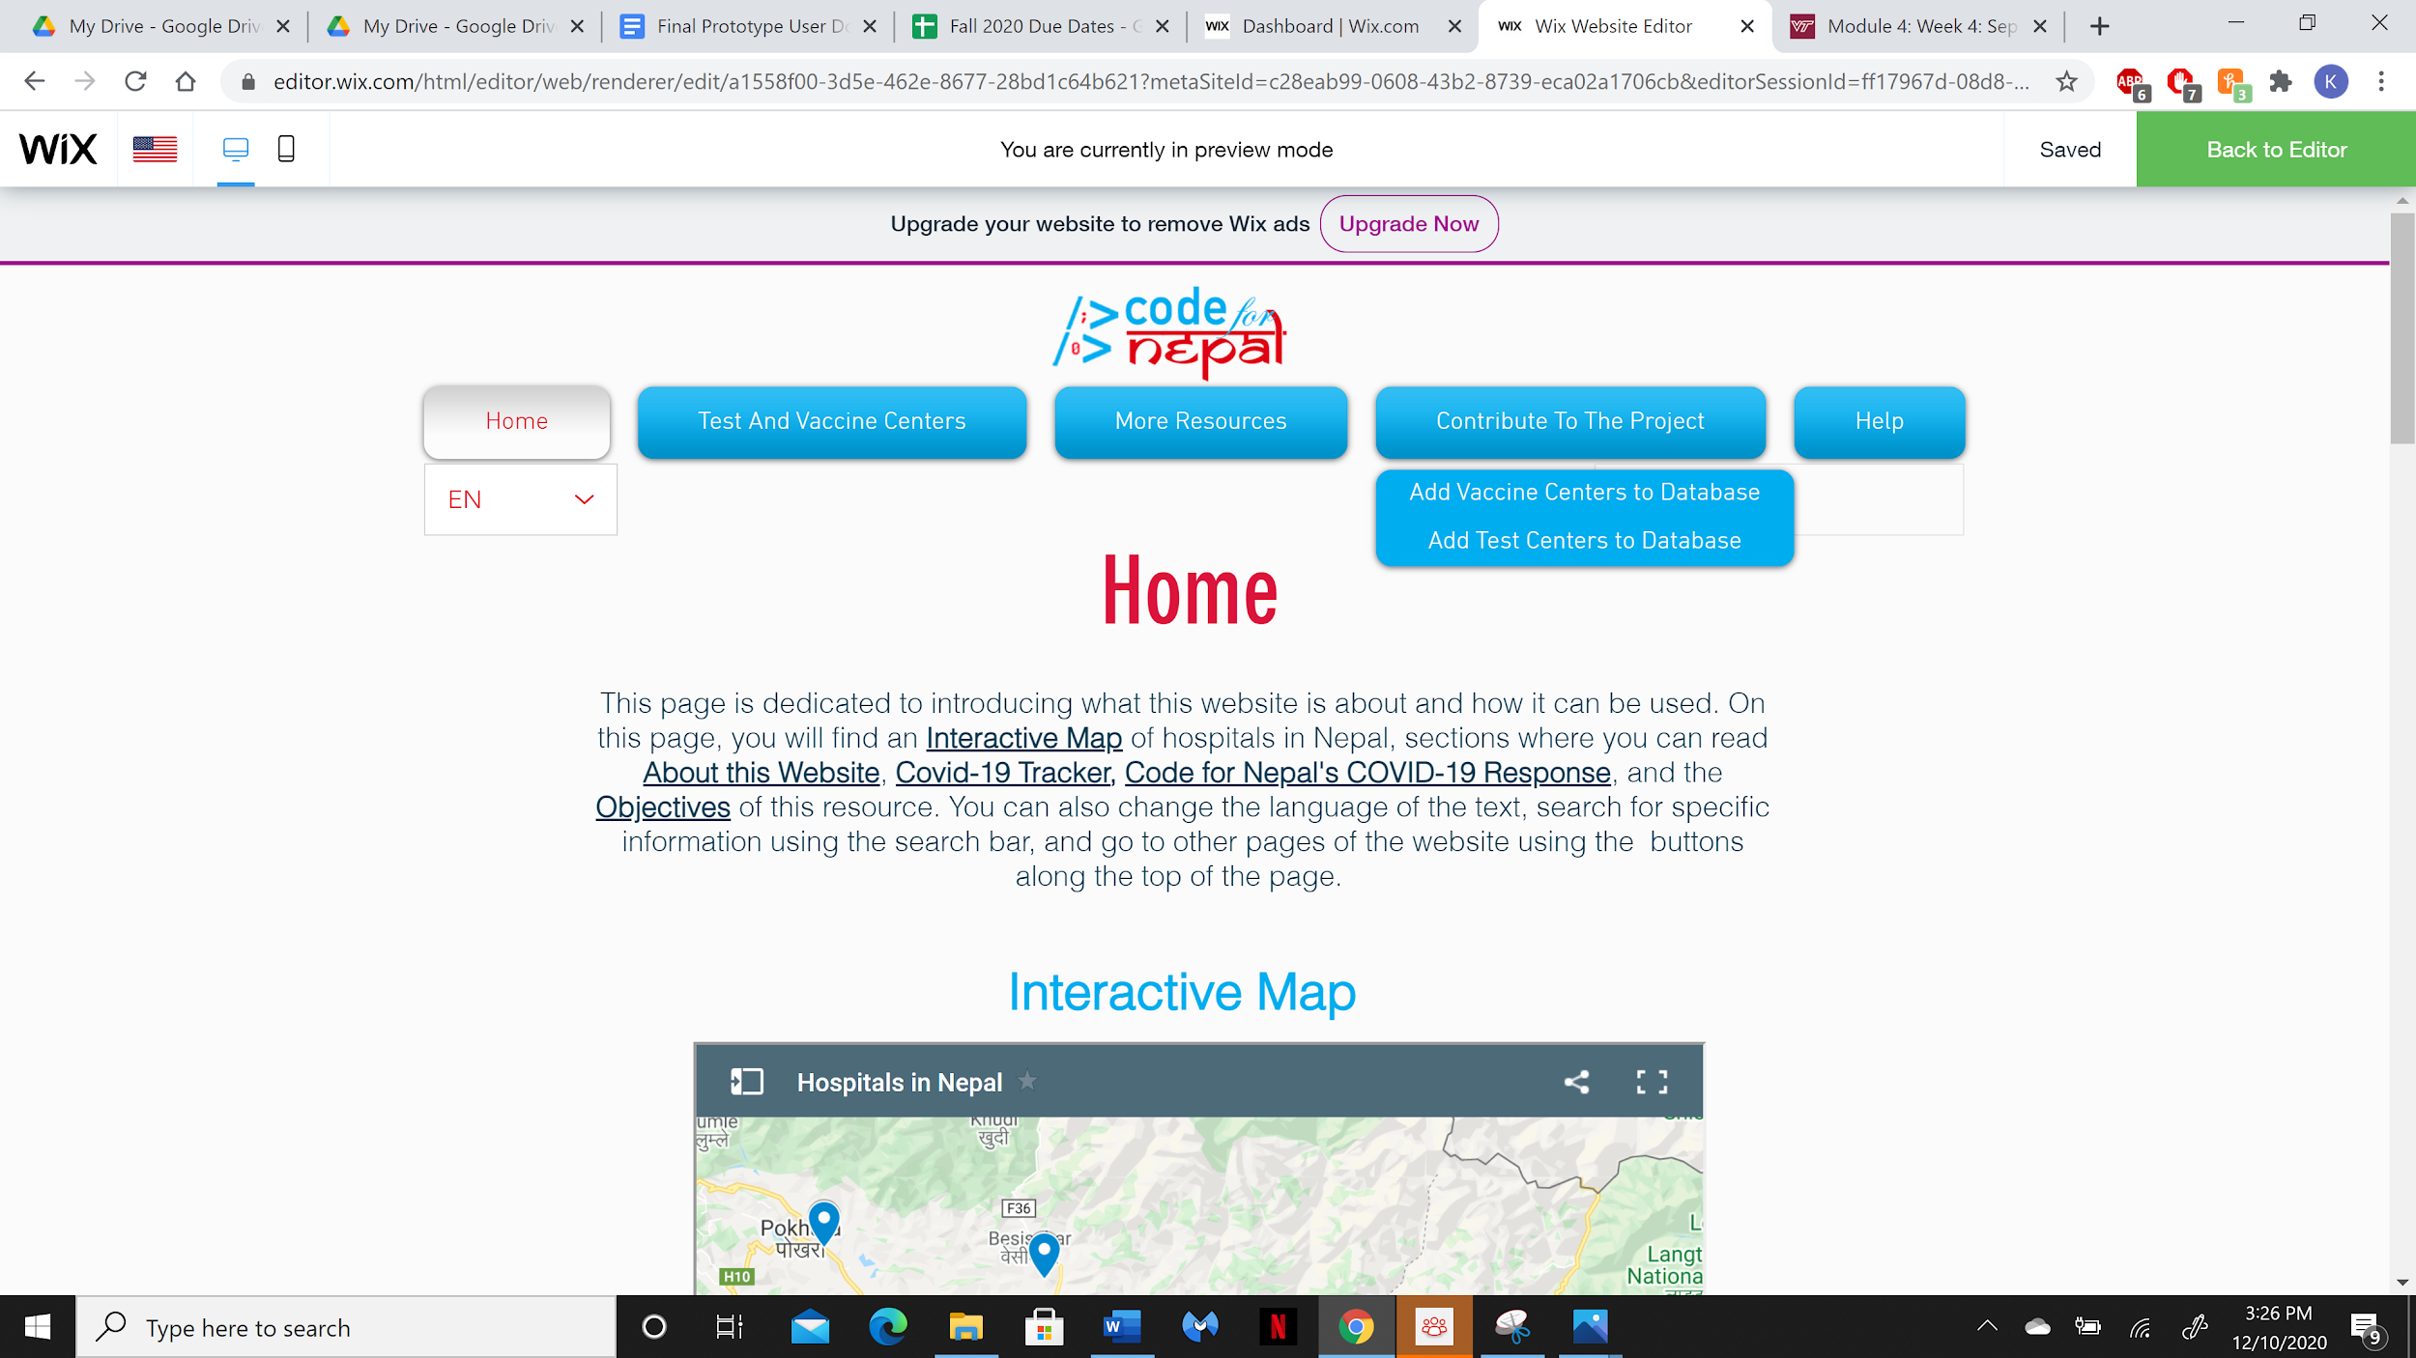

1. Click on the line of text that matches your needs. You will be directed to that page.
2. If you would like additional help navigating the website or more information about Code for Nepal, click the **Help** button. This drop down menu will appear:

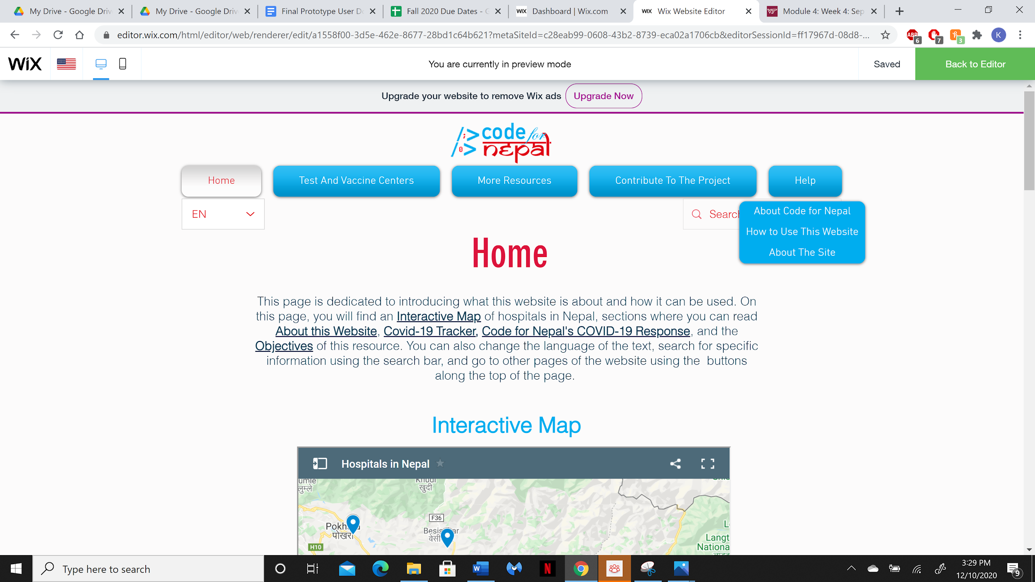

1. Click on the line of text that matches your needs. You will be directed to that page.

**6.) How to find a test center:**

1. Open the Code For Nepal COVID-19 Resource website by typing **[insert HTML link here]** into your internet browser. You should see the home page on your screen, pictured below:



1. Click the **Test and Vaccine Centers** button at the top, outlined in red in the picture below.

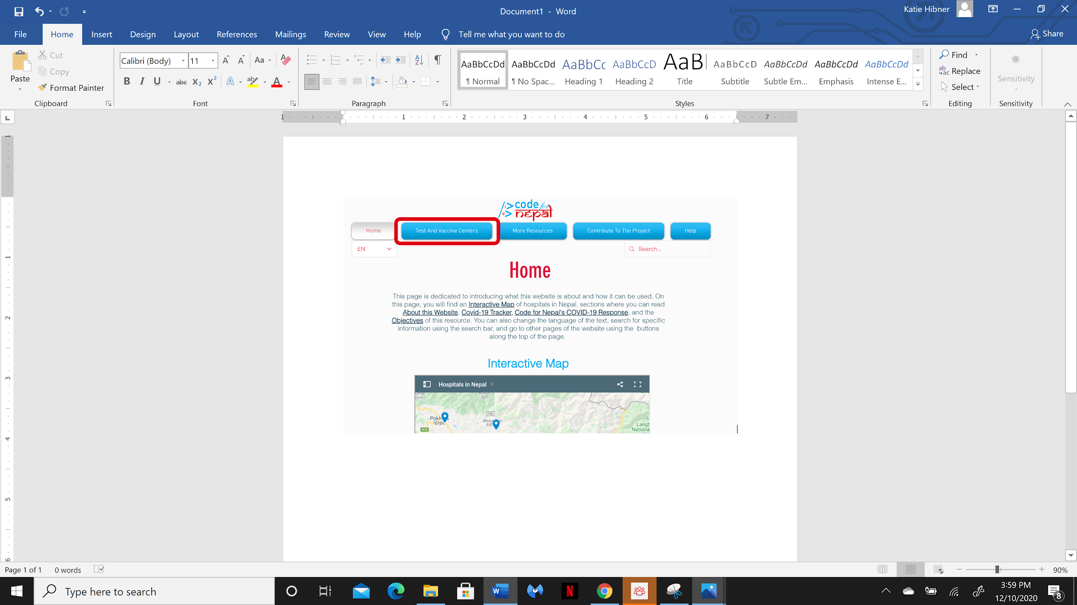

1. Click **Find a Test Center** in the drop down menu, outlined in red in the picture below.

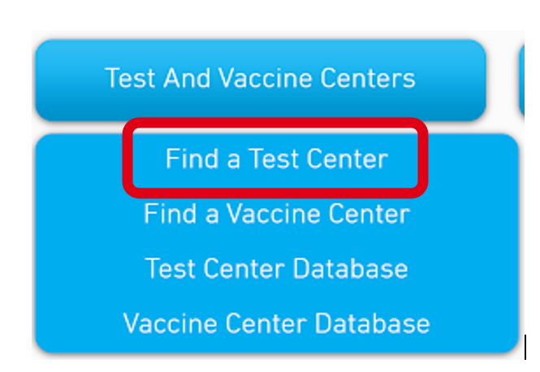

1. This will take you to the **Find a Test Center** page.
2. Place your cursor and click in the search bar labeled **Type the name of your city or town.**
3. Type the name of your city or town in the text box.
4. Click the search icon or press “Enter” on your keyboard to see COVID-19 test centers near you. The search icon is outlined in red in the picture below.

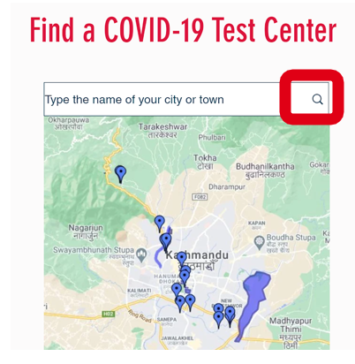

1. Blue markers will show up on the map to label the centers closest to your location. You can click on these markers to find more information about the center.

*The following information can also be found on the COVID-19 Information page.*

**You should seek emergency aid by dialing 102 on a cell phone or landline if you have any of the following symptoms:**

* Trouble breathing
* Persistent pain in the chest
* Confusion
* Inability to stay awake
* Bluish lips or face

**You should seek testing if you have any of the following symptoms:**

* Fever
* Chills
* Nausea
* Diarrhea
* Cough
* Congestion
* Sore Throat
* Eye Pain

You should also seek testing if you have been exposed to someone displaying these symptoms or if you have been exposed to someone who has tested positive for COVID-19. Exposure is defined in more detail in section *1b.) Terminology* on page 4.

**7.) How to find a COVID-19 Vaccine Center**

*This page will be functional when a COVID-19 vaccine becomes available to the public.*

1. Open the Code For Nepal COVID-19 Resource website by typing **[insert HTML link here]** into your internet browser. You should see the home page on your screen, pictured below:



1. Click the **Test and Vaccine Centers** button at the top, outlined in red in the picture below.



1. Click **Find a Vaccine Center** in the drop down menu, outlined in red in the picture below.

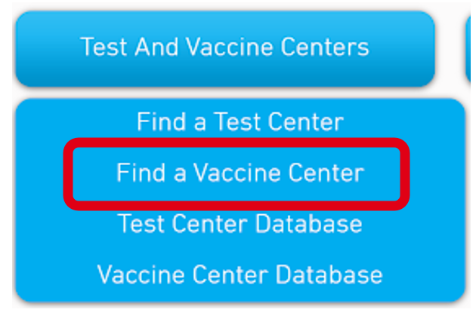

1. This will take you to the **Find a Vaccine Center** page.
2. Place your cursor and click in the search bar labeled **Type the name of your city or town.**
3. Type the name of your city or town in the text box.
4. Click the search icon or press “Enter” on your keyboard to see COVID-19 vaccine centers near you. The search icon is outlined in red in the picture below.



1. Blue markers will show up on the map to label the centers closest to your location. You can click on these markers to find more information about the center.

**8.) How to add a test center to the database:**

To add a test center to our database, follow the steps below. Once you have reported a new test center, our team will evaluate your submission and add it to the database once the information has been verified.

1. Open the Code For Nepal COVID-19 Resource website by typing **[insert HTML link here]** into your internet browser. You should see the home page on your screen, pictured below:



1. Click the **Contribute To The Project** button at the top, outlined in red in the picture below.

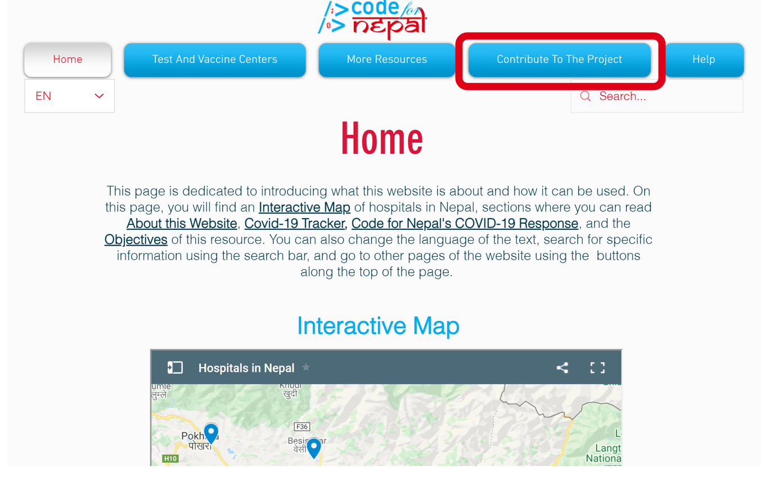

1. Fill out the form pictured below by clicking inside each text box and typing in the correct information. There are also onscreen instructions to help guide you through the form.

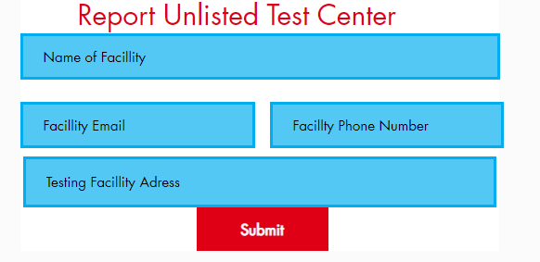

1. Click submit to share the information with the curation team.

**9.) How to add a vaccine center to the database:**

To add a vaccine center to our database, follow the steps below. Once you have reported a new vaccine center, our team will evaluate your submission and add it to the database once the information has been verified.

1. Open the Code For Nepal COVID-19 Resource website by typing **[insert HTML link here]** into your internet browser. You should see the home page on your screen, pictured below:



1. Click the **Contribute To The Project** button at the top, outlined in red in the picture below.



1. Fill out the form pictured below by clicking inside each text box and typing in the correct information. There are also onscreen instructions to help guide you through the form.

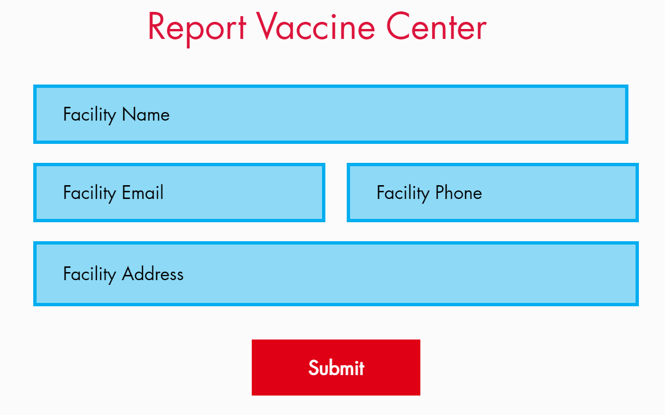

1. Click submit to share the information with the curation team.